**Rock-Paper-Scissors Game Documentation**

**Introduction**

The Rock, Paper, Scissors Game is a Java application that brings the classic hand game to life in a digital format. Unlike traditional versions, this implementation offers a single-player experience where the user competes against the computer's choices. The objective is to make strategic decisions and predict the computer's moves to achieve a winning outcome. This documentation provides an overview of the project structure, key functionalities, and technical aspects, emphasizing the engaging experience of playing Rock, Paper, Scissors against an AI opponent.

**Abstraction**

**‘La’ class**

Encapsulates the logic of the game

* Attributes
* “private int human”- represents the user's choice
* “private int computer”- represents the computer's randomly generated choice

Where 0=Rock

1=Paper

2=Scissors

* “int result” -where 0=Loss

1=Tie

2=Win

* “private Random random”- Randomises the choice of the computer
* Methods
* “public int play()” Generates a random computer choice and returns it
* “public int getComputer()”-Returns the computer's choice
* “public void setHuman(int human)”- Sets humans choice
* “public int checkWinner()”- Compares the human and computer choices to determine the game results as an integer with the aforementioned rule

**‘Pla’ class**

Is responsible for the GUI and user interaction

* Attributes
* “private La rockGame”- Encapsulates the game logic
* “private ImageView viewImage”- Represents GUI element for displaying images
* Methods
* “public void start(Stage primaryStage)”-Sets up the GUI
* “private Button createButton(int choice)” – Abstracts the creation of buttons with images for the different choices
* “private void playGame(int humanChoice)”- Takes as input the choice of the human, abstracts the game logic when a button is clicked
* Functionalities
* Game logic – The game follows the rules of the game Rock, Paper, Scissors
* The first class encapsulates the game logic, generates random computer choices and determines the winner based on the choices
* User Interface – The game provides a graphical user interface using JavaFX
* Components are organized in HBox-es and VBox-es or GridPane
* An ‘ImageView’ is used to display the computer's choice
* Button Clicking- Represent the user's choice
* Result Display- The game displays the results to the console
* Random computer choice
* Abstraction and Encapsulation- The game uses abstraction to hide implemented details

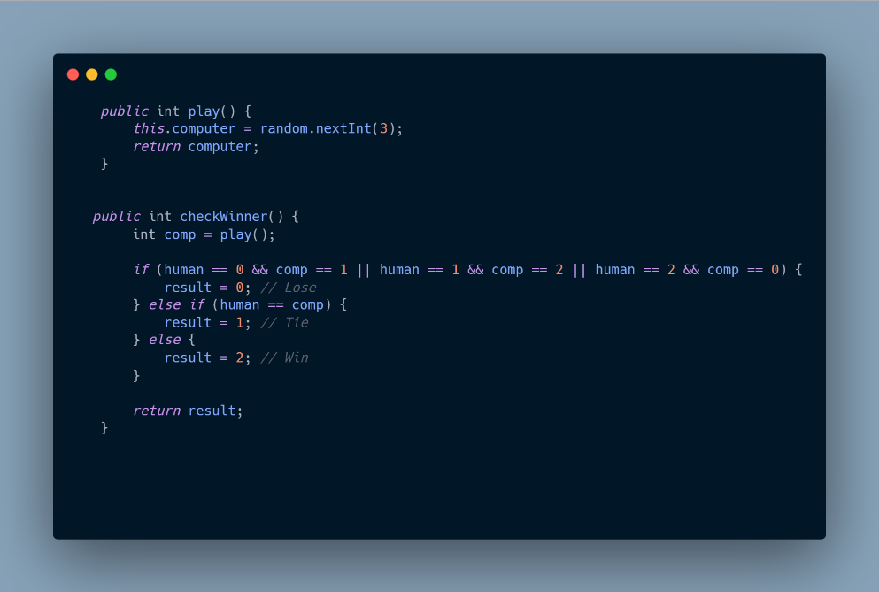 **Methodology**

* Game Logix

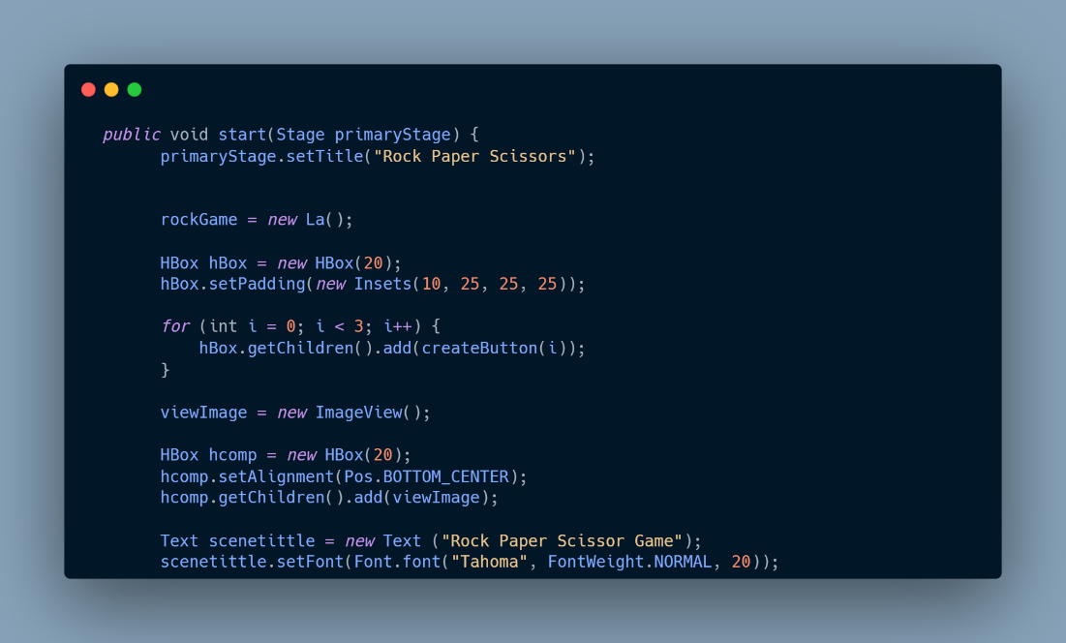

* Scene components

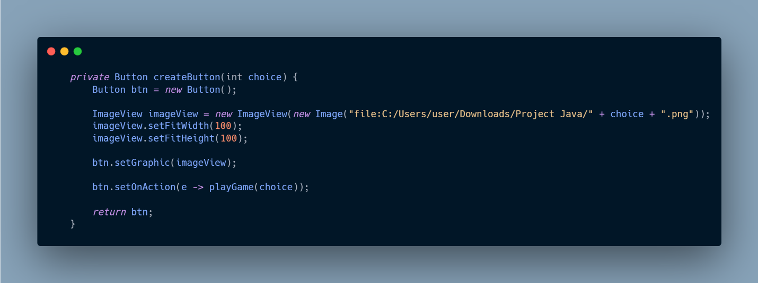

* The Creation of buttons with images from the folder

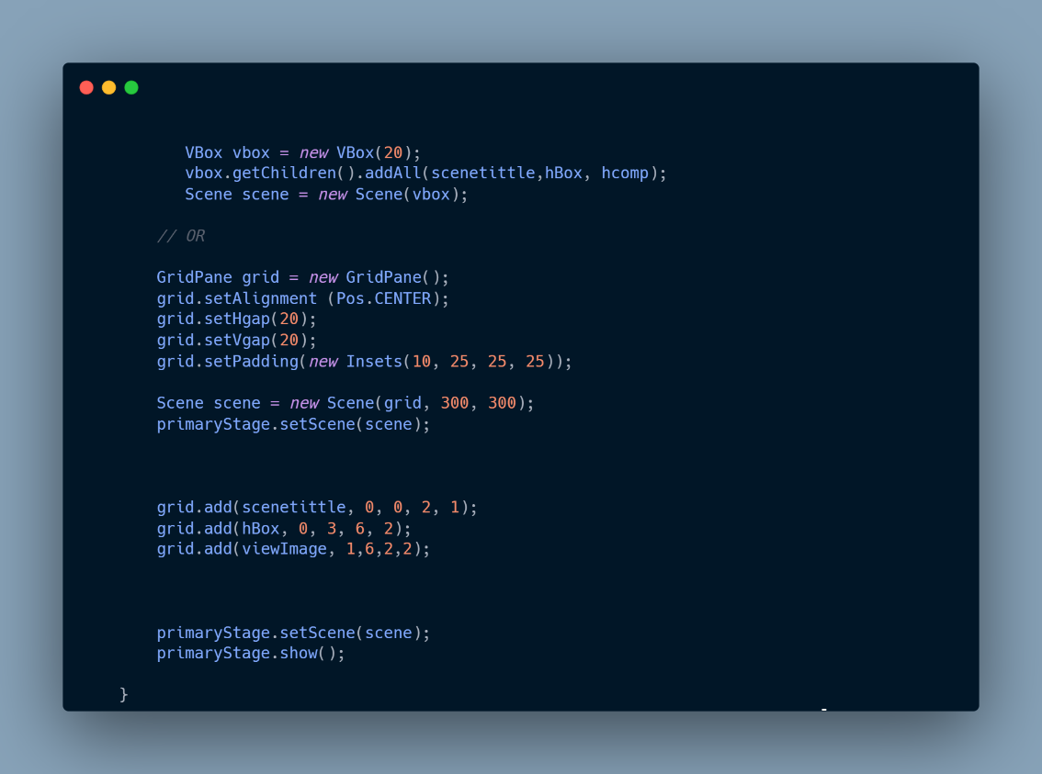

* Scene Layout

(could be a grid or a VBox)

* 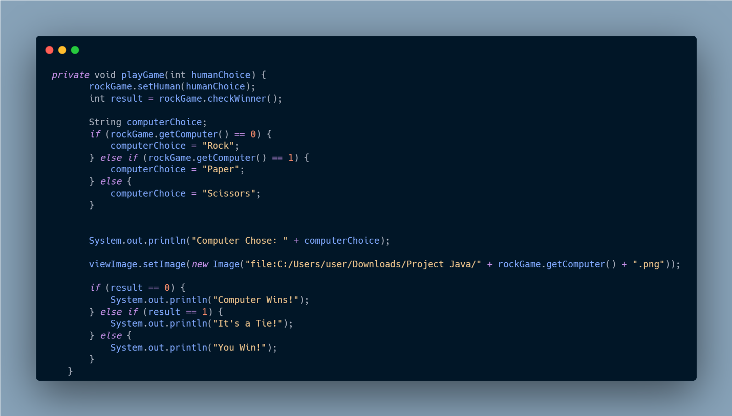Main block of code

Responsible and calls methods for handling the logic when a button is clicked

**What is missing**

* 2 Player Game Mode
* Menu Bar
* Text displayed on the window